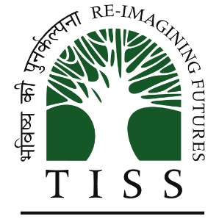

**TATA INSTITUTE OF SOCIAL SCIENCES**

**BS in Analytics and Sustainability Studies**

**Semester III**

**EIA & SIA**

***Sahil (m2022bsass023)***

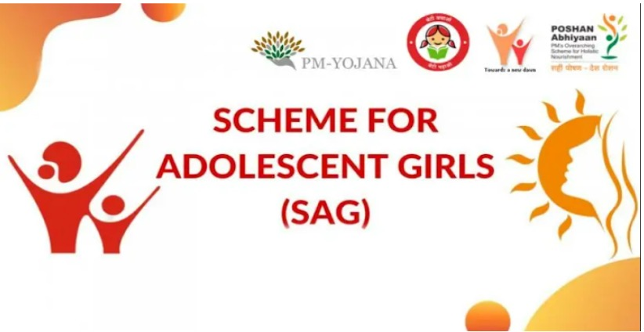

**Rajiv Gandhi Scheme for Empowerment of Adolescent Girls (RGSEAG)**

The Rajiv Gandhi Scheme for Empowerment of Adolescent Girls (RGSEAG), commonly known as **SABLA**, is an initiative by the Central Government of India to uplift and empower adolescent girls nationwide. Introduced on April 1, 2011, with validity extending until March 31, 2015, it encompasses a package of services designed to monitor the essential needs of adolescent girls aged 11 to 18. This initiative includes provisions such as nutritional support, iron and folic acid supplementation, health check-ups, and referral services, alongside crucial elements like nutritional and health education, counselling on family welfare and adolescent reproductive and sexual health (ARSH), and life skill education. Moreover, the scheme offers vocational training opportunities for girls aged 16 and above under the National Skill Development Program (NSDP) to enhance their employability and economic independence. This Scheme highlights and meets the importance of Empowering adolescent girls to advance human rights and achieve gender equality. Providing the Girls with education, healthcare, and economic opportunities allows them to break the cycle of poverty and make informed decisions about their lives. Additionally, empowered girls are more likely to lead healthier lives, delay marriage, and contribute positively to their communities. Investing in the empowerment of adolescent girls yields long-term benefits for individuals, families, and societies.

The services covered under the scheme are: -

a. **Nutrition:** Providing healthy food to the girls.

**b.** **Iron and Folic Acid (IFA) Supplements:** Give them extra vitamins to stay healthy.

**c.** **Health Check-ups:** Ensure they stay well and refer them to doctors if needed.

**d. Nutritional and Health Education:** Teaching them about eating right and staying healthy.

**e. Counselling:** Giving them advice on family, health, and managing their homes.

**f. Life Skills Education:** Teaching them essential skills for life, like decision-making and problem-solving.

**g. Vocational Training:** Offering job skills training for girls aged 16 and above so they can find work.

The funding for SABLA comes from the Central Government, and the state governments or union territories implement it. The scheme's beneficiaries are individual girls and women who benefit from financial aid and informal education. To be eligible for SABLA, girls must be between 11 and 18 years old and fall under Integrated Child Development Services (ICDS) projects in selected districts. This program is divided into two age groups: 11-15 and 15-18, with interventions planned accordingly. Information about SABLA is available at ICDS offices and Anganwadi centres (AWCs), making it easy for girls and their families to access these essential services and opportunities for empowerment

**Problem Tree**

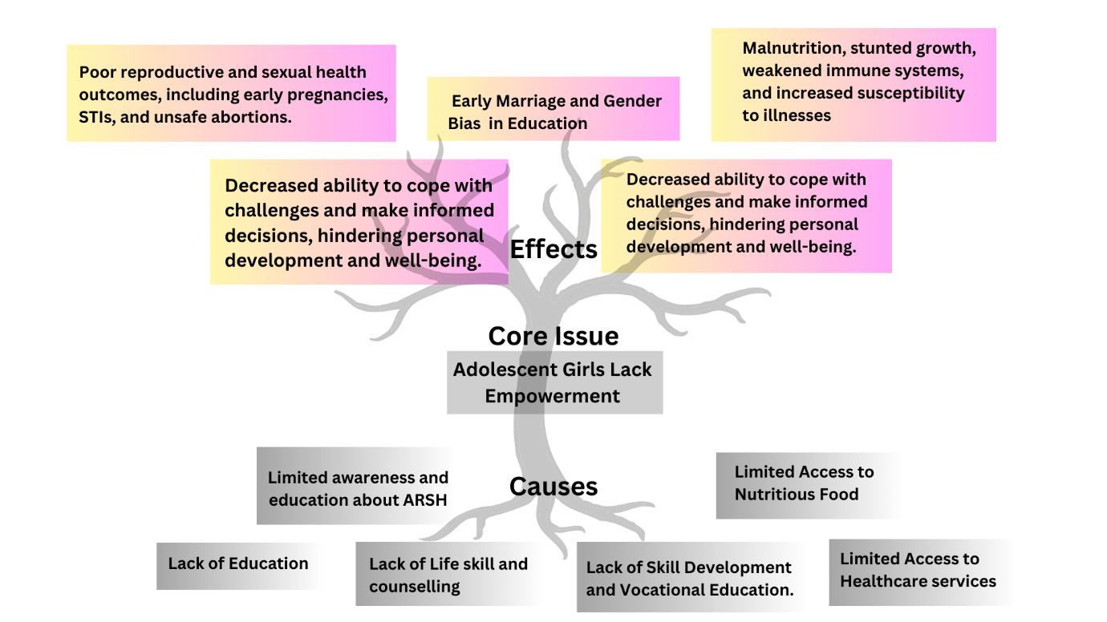

Adolescent reproductive and sexual health (ARSH) is a fundamental component of overall well-being, yet in India, adolescents face significant hurdles due to limited awareness and education. The lack of comprehensive sex education leaves adolescents ill-equipped to navigate the complexities of reproductive health, leading to risky behaviours such as unprotected sex, early sexual debut, and inconsistent contraceptive use. Consequently, this can result in unintended pregnancies, contributing to the perpetuation of intergenerational cycles of poverty and inequality. Moreover, the absence of accurate information about STIs leaves adolescents vulnerable to infections, including HIV/AIDS, gonorrhoea, and chlamydia, which can have far-reaching consequences for their physical health and prospects. Addressing these challenges requires concerted efforts to promote comprehensive sexuality education, ensure access to confidential and youth-friendly healthcare services, and combat prevailing cultural taboos and stigma surrounding reproductive and sexual health issues (Herat et al., 2018).In addition to reproductive and sexual health concerns, adolescents in India also face barriers to accessing healthcare services. Geographical remoteness, particularly in rural and underserved areas, compounds financial constraints and cultural stigmas, making it difficult for adolescents to seek timely medical care and preventive services. This limited access not only exacerbates existing health disparities but also continues cycles of ill health and poverty.

The lack of availability and affordability of essential healthcare services disproportionately affects marginalised groups, including girls from low-income families, tribal communities, and those with disabilities. To address these disparities, it is necessary to strengthen healthcare infrastructure, expand access to affordable and culturally sensitive healthcare services, and implement community-based interventions to improve adolescent health-seeking behaviours. Food insecurity and inadequate nutrition remain pervasive issues affecting adolescents in India, particularly among marginalised communities. Malnutrition, characterised by stunted growth, micronutrient deficiencies, and underweight status, undermines adolescents' physical health and cognitive development, impairing their ability to thrive academically and economically. Poor nutrition weakens immune systems, rendering adolescents more susceptible to infectious diseases and chronic health conditions. Tackling malnutrition requires a multi-faceted approach encompassing interventions such as promoting breastfeeding practices, improving access to nutritious foods, fortifying staple foods with essential nutrients, and providing nutrition education to adolescents and their families. By addressing these multifaceted challenges comprehensively, India can foster its adolescent population's health, well-being, and empowerment, laying the foundation for a healthier and more prosperous future (Gandhi, 2022).

**Objective Tree**

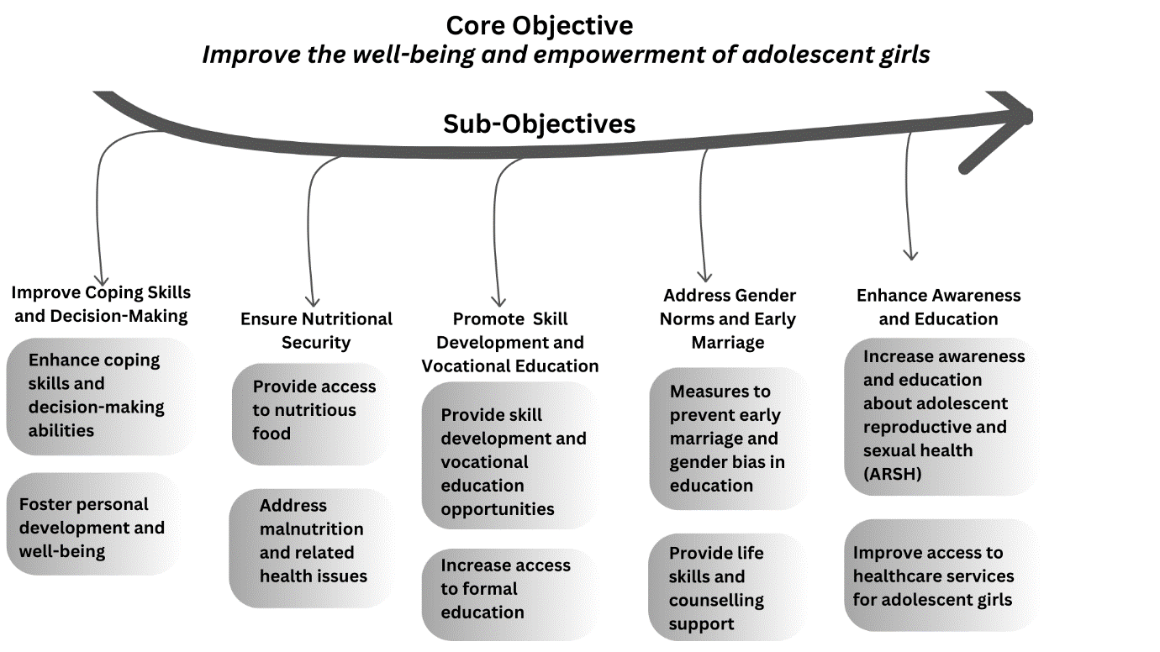

Program Objectives: -

|  |
| --- |
| Enhancing Awareness and Education |
| Ensuring Nutritional Security |
| Promoting Skill Development and Vocational Education |
| Addressing Gender Norms and Early Marriage |
| Improving Coping Skills and Decision-Making |

One of the primary objectives of the program is to enhance awareness and education about adolescent reproductive and sexual health (ARSH), ensuring access to formal education for adolescent girls. By conducting workshops, training sessions, and implementing a comprehensive sexuality education curriculum in schools, the program aims to empower adolescent girls with knowledge and understanding of ARSH, thereby increasing school enrollment and retention rates. Another vital objective is to provide access to nutritious food and address malnutrition and related health issues among adolescent girls. Through implementing nutrition supplementation programs, promoting kitchen gardens, and providing nutrition education, the program seeks to improve the nutritional status and health outcomes of adolescent girls, ultimately reducing the prevalence of malnutrition in the target population. The program promotes skill development and vocational education opportunities for adolescent girls. Establishing vocational training centres, offering skill-building workshops and courses, and providing apprenticeship and internship opportunities are integral activities to enhance employability and economic empowerment among adolescent girls, leading to increased income generation. An essential objective of the program is to address gender norms and prevent early marriage among adolescent girls. By conducting community awareness campaigns, advocating for policy reforms, and providing scholarships and incentives to promote girls' education, the program seeks to delay the age of marriage, reduce dropout rates among girls, and manage gender equality within communities. Lastly, the program aims to enhance adolescent girls' coping skills and decision-making abilities, providing them with life skills and counselling support. Establishing counselling centres or hotlines, conducting peer support groups and mentoring programs, and offering workshops on stress management and conflict resolution are crucial activities to improve mental health and well-being, increase self-esteem, and build resilience among adolescent girls.

Impact Areas

The program's activities are intended to achieve measurable impacts in critical areas, including:

|  |
| --- |
| 1. Improved knowledge and understanding of ARSH among adolescent girls. |
| 2. Increased school enrolment and retention rates. |
| 3. Enhanced nutritional status and reduced prevalence of malnutrition. |
| 4. Enhanced employability and economic empowerment. |
| 5. Delayed age of marriage and reduced dropout rates among girls. |
| 6. Promotion of gender equality within communities. |
| 7. Improved mental health and well-being, increased self-esteem, and resilience among adolescent girls. |

**Activities: -**

To accomplish the program objectives and impact areas, the following activities must be implemented:

1. Conducting workshops and training sessions on ARSH education.

2. Distributing informational materials on ARSH and formal education.

3. Implementing comprehensive sexuality education curriculum in schools.

4. Implementing nutrition supplementation programs and promoting nutrition education.

5. Establish vocational training centres and offer skill-building workshops.

6. Providing apprenticeship and internship opportunities.

7. Conducting community awareness campaigns on gender norms and early marriage.

8. Advocating for policy reforms to promote girls' education and gender equality.

9. Providing scholarships and incentives for girls' education.

10. Establishing counselling centres or hotlines and conducting peer support groups and mentoring programs.

11. Offering workshops on stress management and conflict resolution.

**Conclusion**

In conclusion, the program design derived from the problem tree analysis demonstrates a comprehensive approach to addressing challenges faced by adolescent girls in India. By identifying key issues such as limited awareness of reproductive and sexual health, inadequate access to healthcare services, nutritional insecurity, lack of skill development opportunities, gender norms, early marriage, and insufficient coping skills, the program aims to tackle root causes while achieving development and empowerment among adolescent girls. One of the strengths of the program design lies in its recognition of the interconnectedness of various issues impacting adolescent girls' well-being. By addressing these issues through awareness-raising activities, capacity-building initiatives, policy advocacy, and community engagement, the program endeavours to create sustainable changes at the individual, community, and societal levels. Despite its comprehensive approach, the program design faced several challenges in implementation. These challenges include resource constraints, cultural barriers, and resistance to change, particularly in conservative communities where gender norms and early marriage are deeply entrenched. Moreover, the sustainability of program interventions beyond the initial implementation phase may require long-term commitment and investment from governmental and non-governmental authorities. Furthermore, while the program aims to empower adolescent girls, it is essential to ensure that interventions are inclusive and sensitive to the diverse needs and experiences of all adolescents, including those from marginalised communities and those with disabilities.

In conclusion, while the program design demonstrates a commendable effort to address the complex challenges faced by adolescent girls in India, its success depends on practical implementation, sustained commitment and adaptability to evolving contexts and needs. By critically evaluating the program design in light of the problem tree analysis, one can identify areas of strength and opportunities for enhancement, ultimately promoting adolescent girls' well-being and empowerment in India.

**Gaps**

Upon critically reviewing the program design derived from the problem tree analysis, several gaps in implementation need to be noticed, which may block the program's effectiveness in addressing the identified challenges faced by adolescent girls.

From the problem tree identified, it is evident that cultural norms, early marriage, and gender bias are significant barriers to adolescent girls' empowerment. However, the program design needs more emphasis on community engagement and ownership. With active involvement and support from community leaders, parents, and guardians, efforts to challenge deep-rooted norms and practices may overcome resistance and limited impact. The problem tree highlighted limited access to healthcare services and education, particularly in rural and underserved areas. However, the program design must adequately address the logistical challenges of reaching remote and marginalised communities. Targeted outreach and service delivery strategies are necessary for adolescent girls in these areas to avoid barriers to accessing essential resources and support. There needs to be more focus on Intersectionality. At the same time, the problem tree identified gender norms and early marriage as critical challenges; it is necessary to recognise that adolescent girls' experiences are shaped by intersecting factors such as socioeconomic status, ethnicity, disability, and sexual orientation. The program design may need a more nuanced understanding of intersectionality, leading to interventions that do not fully address all adolescent girls' diverse needs and experiences. The problem tree highlighted gaps in healthcare services and education, but the program design may need to sufficiently prioritise capacity building for service providers. Without adequate training and support, healthcare providers, teachers, and other frontline workers may lack the skills and knowledge to deliver quality services and support to adolescent girls effectively. Addressing these gaps in implementation will be critical for ensuring the program's success in empowering adolescent girls and addressing the complex challenges they face. By addressing these gaps, the program can enhance its effectiveness and contribute to meaningful change in the lives of adolescent girls in India.

**References**

Banerjee, A., Karar, A., Ghosh, N., Bhattacharyya, I., & Adhikari, S. (2023). Empowering Adolescent Girls during a Global Pandemic: An Initiative through the Scheme for Adolescent Girls and the Kanyashree Prakalpa Convergence (SAG-KP) Program. *Children, Youth and Environments*, *33*(2), 197–206. https://doi.org/10.1353/cye.2023.a903105

Gandhi, A. B. (2022). Diet and Weight Management in Adolescent Girls. *The Journal of Obstetrics and Gynecology of India*, *72*(2), 175–177. https://doi.org/10.1007/s13224-022-01647-6

Herat, J., Plesons, M., Castle, C., Babb, J., & Chandra-Mouli, V. (2018). The revised international technical guidance on sexuality education—A powerful tool at an important crossroads for sexuality education. *Reproductive Health*, *15*(1), 185, s12978-018-0629–x. https://doi.org/10.1186/s12978-018-0629-x